** SOHAIB ANJUM 65309**

**PAF-Karachi Institute of Economics and Technology College of Computing and Information Sciences**

DATA COMMUNICATION & NETWORKING-111732

**Assignment – 2**

**\*IMPORTANT INSTRUCTIONS:**

**Read the following Instructions carefully:**

* Attempt all questions.
* Add screenshot of each question’s solution with output.
* Try all the questions yourself. If the solution is copied, the task will be marked as ZERO.
* Arrange questions and their subsequent parts in sequence.
* Deadline 14-Apr-2023.
* Save your word document with name: [Student Name Student ID].

**[5 mark]**

**Q1**. Design a Ring Network which consist of 3 routers use serial cable between routers attach 3 PC’s with each router with the help of switch DNS and Email server on router 3 switch at the end of the configuration any two of the router-3 users can send and receive email to each other. Both the user should be on your name while all the devices also should be on your name. Print network diagram, all 3 routers configuration image, Email server and DNS server image.

**RESULT**

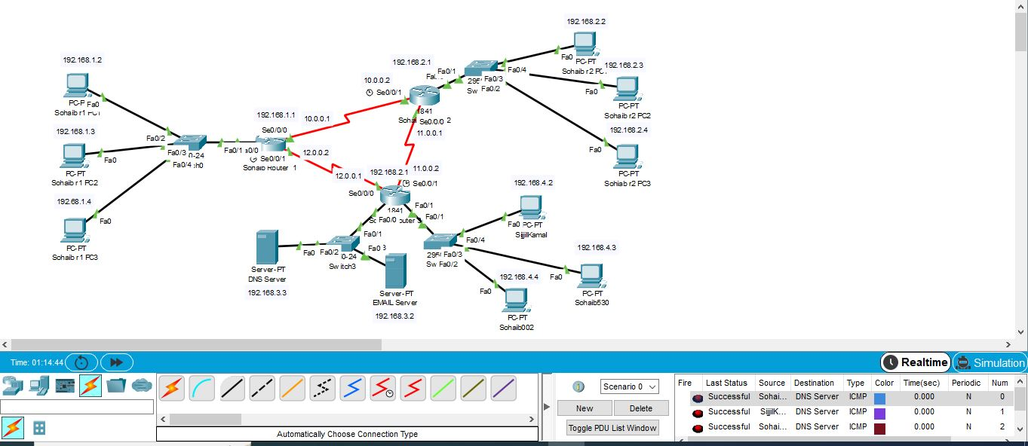

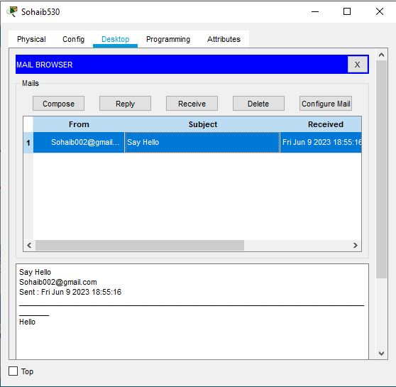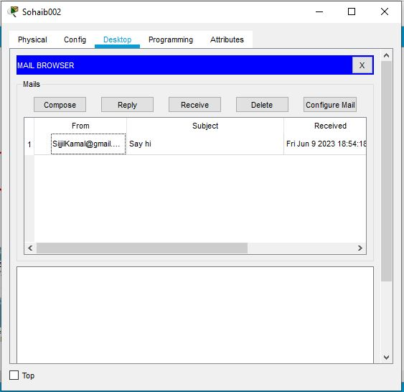

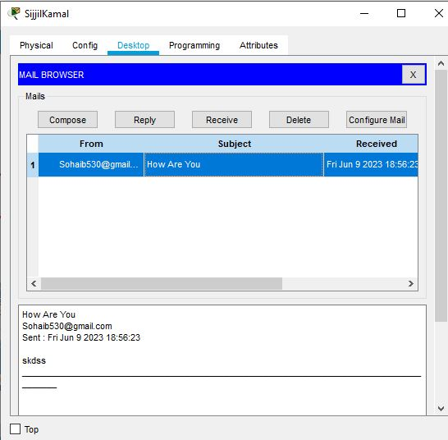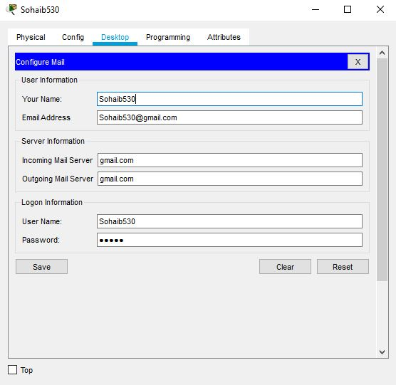

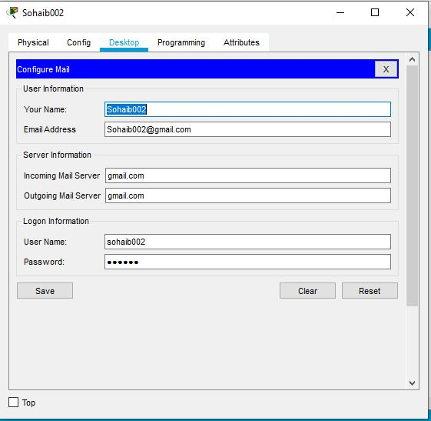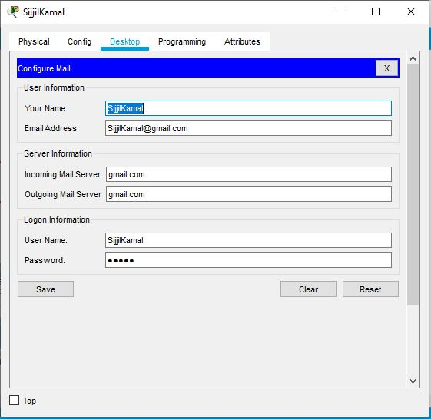

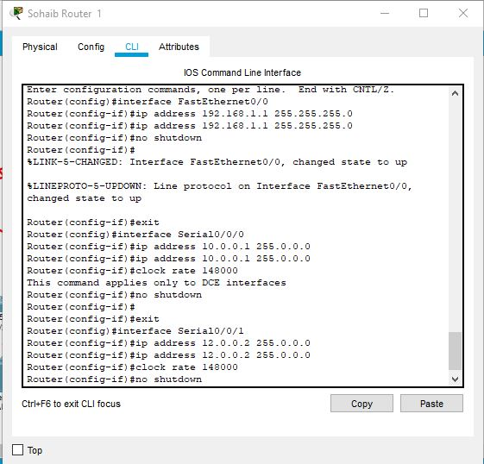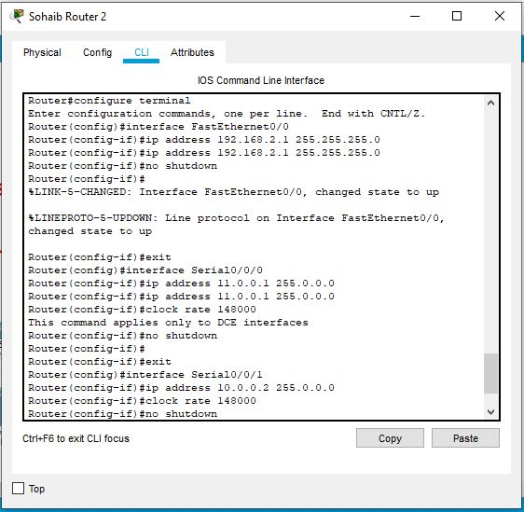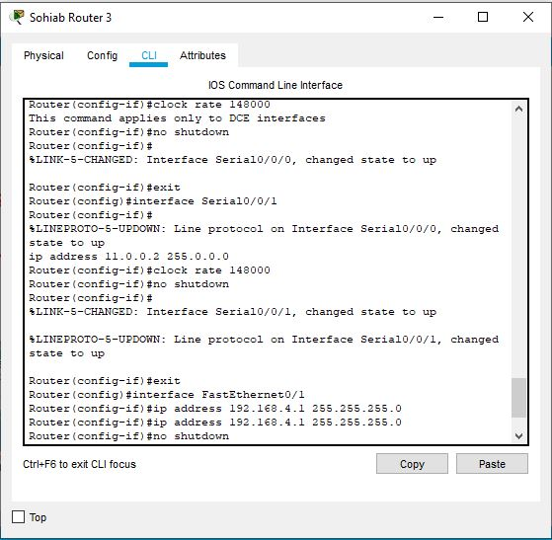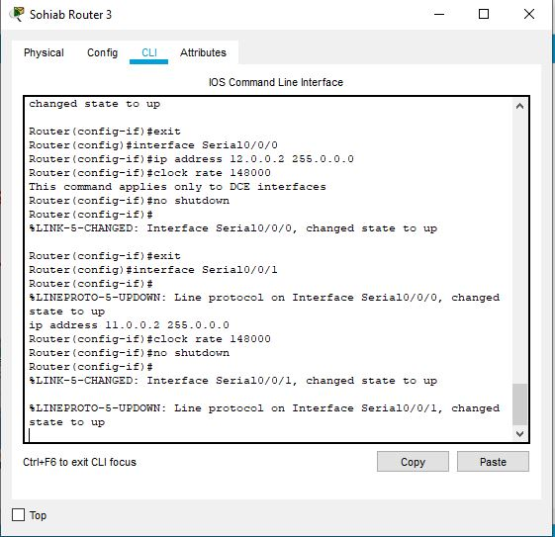

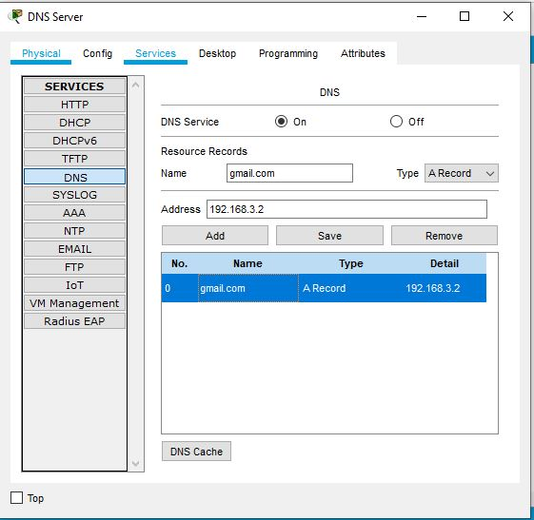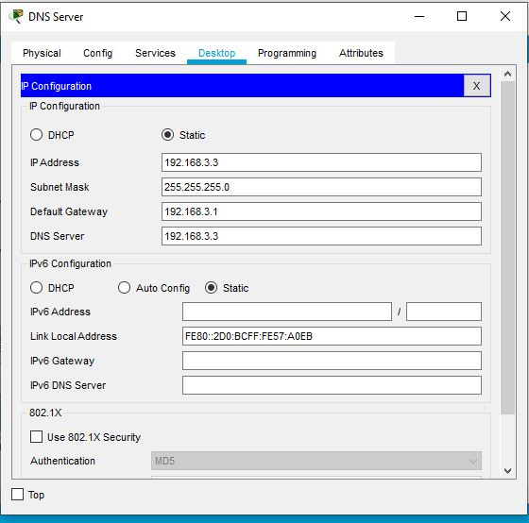

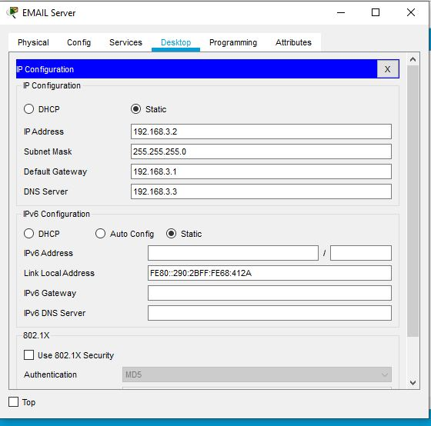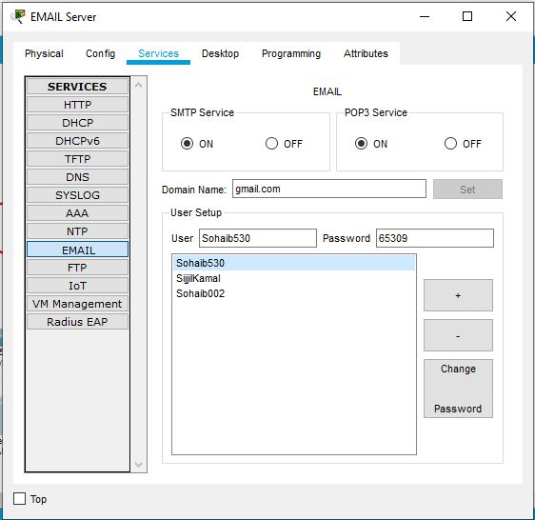

**[5 mark]**

**Q2.** Design a Bus Network which consist of 3 routers attach 3 PC’s with each router with the help of switch also attach DNS server a web server from router to switch. At the end of the configuration user-4 should be able to access the webpage. Webpage should be on your name

